UNIT-IV
RADIO TRANSMITTERS & RECEIVERS
Syllabus:
Radio Transmitters: Classification of Transmitters, AM Transmitter, Effect of feedback on performance of AM Transmitter, FM Transmitter: Variable reactance type and Phase modulated FM Transmitter, Frequency stability in FM Transmitter.
Radio Receivers: Receiver Types: Tuned radio frequency receiver, Super heterodyne receiver, RF section and Characteristics, Frequency changing and tracking, Intermediate frequency, AGC, FM Receiver, Amplitude limiting, Comparison of FM & AM Receivers, Communication Receivers, Extension of super heterodyne principle and additional circuits.

FUNCTION OF TRANSMITTER
A transmitter is an electronic device used in telecommunications to produce radio waves in order to transmit or send data with the help of an antenna. The transmitter is able to generate a radio frequency alternating current that is then applied to the antenna, which, in turn, radiates this as radio waves.
RADIO TRANSMISSION
After modulation, the radio waves are transmitted over long distances with the help of electronic circuits called transmitters. The simplest form of transmitter consists of an oscillator, generating a high frequency wave connected to an antenna. In this section, we shall discuss the amplitude and frequency modulated transmitters.
BLOCK DIAGRAM OF RADIO TRANSMITTER
Transmitter takes the information to be communicated in electrical form and convert it into an electronic signal compatible with the communication medium.
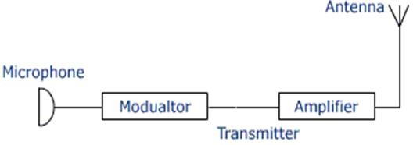
The main parts of transmitter are explained as follows
- Microphone: It converts sounds into electrical signals in wires. It is the opposite of a loudspeaker.
- Modulator: The audio signal is modulated into the radio frequency carrier in this modulator stage.
- Frequency generator: The frequency generation stage will decide the frequency on which the transmitter will operate.
- RF power amplifier: The power amplification of the radio signal is carried out in the final stage. It makes the signal stronger so that it can be transmitted through the channel over long distances.
- Antenna: It is a transducer which converts electrical signals into electromagnetic waves.

BASIC FUNCTIONS OF TRANSMITTER
Transmitter is an electronic unit which accepts the information signal to be transmitted and converts it into an RF signal capable of being transmitted over long distances.
Every transmitter has three basic functions as follows:
- The transmitter must generate a signal of correct frequency at a desired point in the spectrum.
- Secondly it must provide some form of modulation to modulate the carrier.
- Third it must provide sufficient power amplification in order to carry the modulated signal to a long distance.
CLASSIFICATION OF RADIO TRANSMITTERS
The radio transmitters are classified based on the following parameters
- According to the type of modulation used – CW, AM and FM Transmitters
- According to service involved - Radio broadcast transmitters, Radio telephony transmitters, Radio telegraph transmitters, Television transmitters, Radar transmitters, Navigational transmitters.
- According to the frequency range involved - Low frequency (LF), Medium frequency (MF), High frequency (HF), Very high frequency (VHF), Ultra high frequency (UHF) and Microwave transmitters.
- According to the power used - Low Level modulation transmitters, High Level modulation transmitters.
- ACCORDING TO THE TYPE OF MODULATION USED
  - CONTINIOUS WAVE (CW) TRANSMITTERS:
    - The CW Transmitter is the simplest type of transmitter.
    - It is a simple crystal oscillator circuit.
    - This oscillator generates a carrier signal of the desired frequency.
    - Information to be transmitted is expressed in a special form of code using dots and dashes to represent letters of the alphabet and numbers.
    - The information transmitted in this way is called as continuous wave (CW) transmission.
    - The key is a simple hand operated switch connected in emitter of the transistor.
    - By closing the key we can turn on the crystal oscillator on and by opening the key the oscillator is turned off.
    - When the key is closed, the oscillator produces a sinusoidal signal at a frequency equal to the crystal frequency, whereas with the key open, the output of oscillator is zero.
    - The key is opened and closed in order to produce zero output and dots or dashes.
    - Dots correspond to the short duration output whereas a dash corresponds to a long duration output.
    - The required messages can be transmitted using different combinations of dots and dashes for different alphabets and letters.

ADVANTAGES OF CW TRANSMITTER
    - Simple to construct
    - Compact and portable
    - Can be operated on batteries
DISADVANTAGES OF CW TRANSMITTER
    - A skilled operator is required to convert the message to be sent into a coded form of dots and dashes.
    - Long distance communication is not possible.
    - Voice or picture can’t be sent.
  - AMPLITUDE MODULATED (AM) TRANSMITTER
AM Transmitter consists of two sections
(i) Audio frequency (AF) section and (ii) Radio frequency (RF) section.
AF section: The AF section of the transmitter generates the modulating wave (signal). The conversion of sound energy into electrical energy is performed by the microphone.
RF section: In the RF section, the high frequency carrier wave is generated by a crystal controlled oscillator. The output of the crystal controlled oscillator is power amplified by RF power amplifier.
  - FREQUENCY MODULATED (FM) TRANSMITTER
Frequency modulated systems are operated usually at a frequency above 40 MHz. Frequency modulated broadcasting is done in television sound, mobile radio etc. It consists of a crystal oscillator, which produces the carrier wave and the output of this is fed into the phase modulator. The buffer is a low frequency amplifier which isolates the crystal oscillator from the phase modulator.
- ACCORDING TO SERVICE INVOLVED
  - Radio broadcast transmitters: An electronic device which radiates radio waves modulated with information content intended to be received by the general public.
  - Radio telephony transmitters: The transmitter in the telephone converts acoustical energy into electrical energy. A part of the telephone circuitry sends some of the electrical energy from the transmitter to the receiver so that the user can hear their own voice. This is called sidetone.
  - Radio telegraph transmitters: Radiotelegraphy is used for certain types of marine ship-to-shore communication (such as emergency calls), for weather and sea state bulletins by national maritime services, for point-to-point communication between fixed points on the Earth's surface, for amateur radio communications, and for various special services. Radiotelegraphy, or wireless telegraphy, involves the transmission of messages using radio. Telegraphy includes recent forms of data transmission such as fax, email, and computer networks in general. A telegraph is a machine for transmitting and receiving messages over long distances, that is, for telegraphy.
  - Television transmitters: A television transmitter is a transmitter that is used for terrestrial (over- the-air) television broadcasting. The main principle of this circuit is to transmit the audio and video signals. Here audio signals are frequency modulated and video signals are PAL modulated. These

modulated signals are applied for the antenna. VHF (Very High Frequency) band having frequency range 30 MHz to 300 MHz is typically used for TV and radar transmission.
  - Radar transmitters: The function of the radar transmitter is to generate an electromagnetic signal to illuminate the target. Radar level transmitters work with high-frequency radar pulses which are emitted by an antenna and reflected from the product surface. The time of flight of the reflected radar pulse is directly proportionate to the distance traveled. the transmitter consists of a waveform generator synchronous to an oscillator reference, an up-converting stage, a power amplifier, and an antenna.
  - Navigational transmitters: In navigational systems the transmitters broadcast sufficient information so that the location can automatically be calculated and displayed. In addition, there are specialized beacons and location markers, like those used at airports, to provide guidance for an aircraft. Radio navigation systems consist of networks of transmitters that allow the user to locate his position in relation to the network, and hence themselves.
- ACCORDING TO THE FREQUENCY RANGE INVOLVED
  - Low frequency (LF) transmitters (30 KHZ- 300KHZ).
  - Medium frequency (MF) transmitters (300 KHZ-3 MHZ).
  - High frequency (HF) transmitters (3 MHZ- 30MHZ).
  - Very high frequency (VHF) transmitters (30MHZ-300 MHZ).
  - Ultra high frequency (UHF) transmitters (300 MHZ- 3GHZ).
  - Microwave transmitters (>3GHZ).
- ACCORDING TO THE POWER USED
There are two types of AM transmitters are available based on power level as .
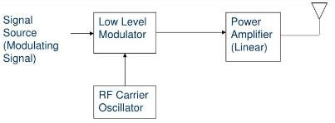
  - LOW LEVEL AM TRANSMITTERS

    - The generation of AM wave takes place at a low power level.
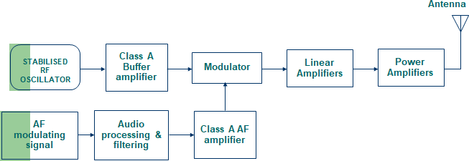
    - The generated AM signal is then amplified using a chain of linear amplifier ( A , AB or B).

    - The RF oscillator produces the carrier signal. The RF oscillator is stabilized in order to maintain the frequency deviation within the prescribed limit. The carrier frequency is equal to the transmitter frequency.
    - Usually the transmitter operates on assigned frequencies or channels. Crystal provides the best way to obtain the described frequency with good stability.
    - We cannot use the LC oscillator because they have low frequency stability.
    - The carrier signal from the crystal oscillator is applied to the modulator with a modulating signal. At the output of the modulator we get the AM wave.
    - The modulating signal is obtained from a source such as a microphone and applied to a buffer processing unit.
    - The buffer is a class A amplifier which isolates the AF source from the rest of high power circuit and amplifies it to an adequate level.
    - The amplified modulating signal is applied to the modulator along with the carrier. At the output of the modulator we get the AM wave.
    - The AM signal is then amplified using a chain of linear amplifier to raise the power level.
    - The linear amplifier can be class A, AB or B type amplifiers. The linear amplifier are used in order to avoid the wave form distortion in AM wave.
    - The amplitude modulated signal is then transmitted using transmitted antenna.
    - The transistorized modulator circuits can be used for low level modulator due to the low power which is to be handled.
    - The low level transmitter does not require a large AF modulator power so its design is simplified.
    - Overall efficiency is much lower compared to high level modulation . This reduce to the use of less efficient linear amplifiers.
    - Audio Processing:
      - The AF modulating signal is passed through an audio processing unit before applying it to the modulator.
      - This block carries out some form of “speech processing” in the form of filtering and amplitude control.
      - The weak signals amplified automatically with a higher gain and strong signals are amplified with smaller gain. This will bring all the signals to a sufficient level.
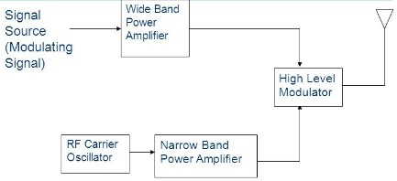
  - HIGH LEVEL AM TRANSMITTERS.

    - The generation of AM wave takes place at high power levels.
    - Highly efficient class C amplifier are used in high level modulation.
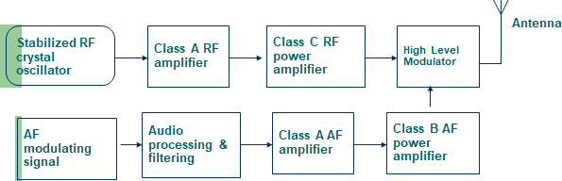
    - Efficiency is more than low level modulation.
    - Many of the AM transmitters use the high level modulation technique.
    - The crystal oscillator produces the required carrier signal. The class A amplifier following the oscillator acts as a buffer which isolates the oscillator from the high power circuit.
    - The output of this class A amplifier is applied to a class C power amplifier. It raises the power level of the carrier to an intermediately high value.
    - The AF modulating signal is applied to the audio processing unit which processes this signal as discussed in the previous section.
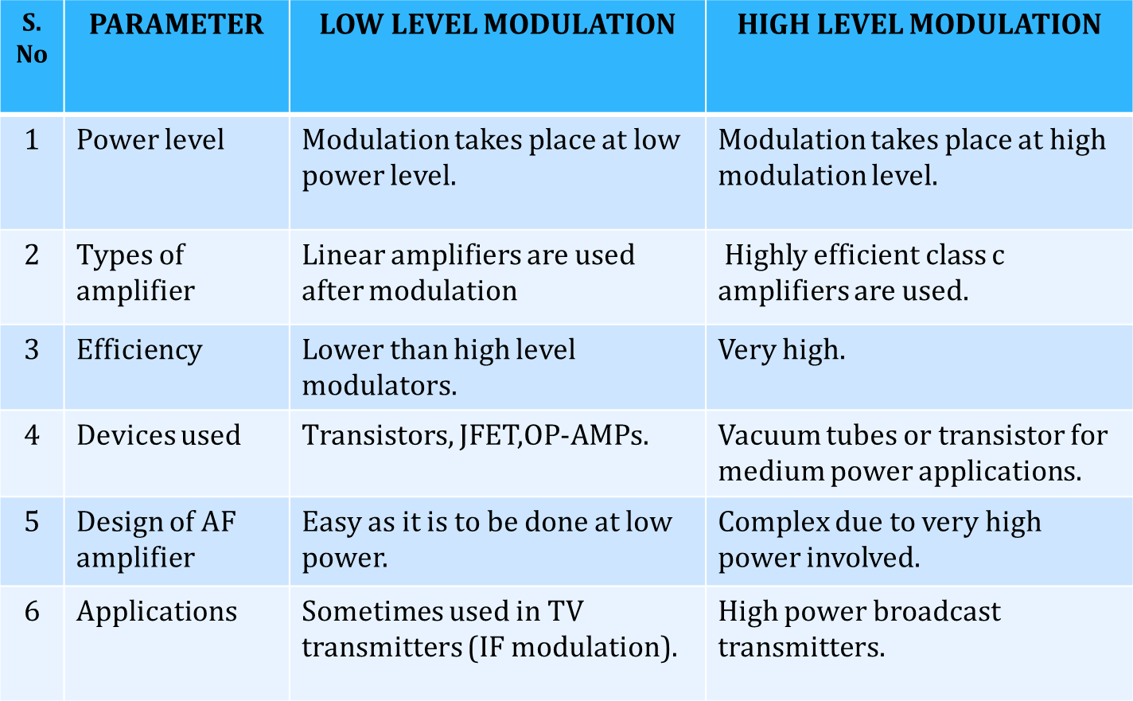
Differences between Low level and High level Modulation

AMPLITUDE MODULATED (AM) TRANSMITTER
Figure gives the block diagram of amplitude modulated radio transmitter. It consists of two sections
(i) Audio frequency (AF) section and (ii) Radio frequency (RF) section.
AF section: The AF section of the transmitter generates the modulating wave (signal). The conversion of sound energy into electrical energy is performed by the microphone.
The electrical energy available from the microphone is very low. Hence, it is amplified through an amplifier. The output from the AF amplifier is fed to the AF power amplifier. The power amplifier provides the required audio frequency power. The output of the AF power amplifier is given to the modulator. A modulator is an electronic circuit with transistor and passive components, which performs the process of modulation.
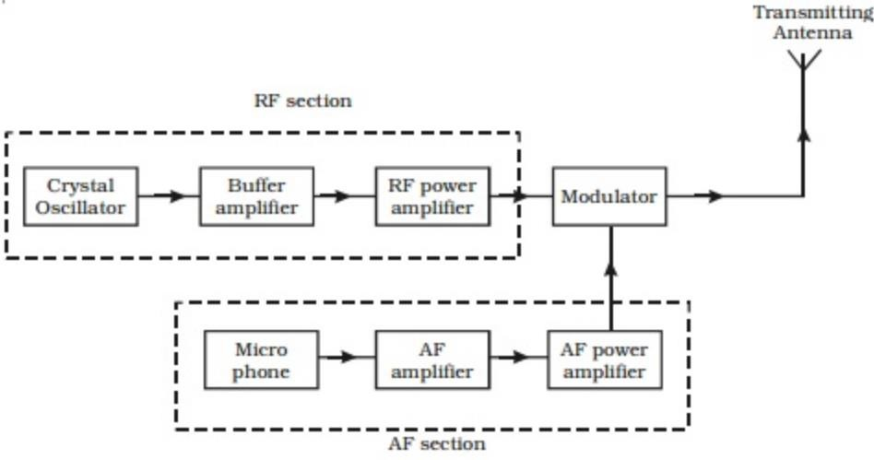
RF section: In the RF section, the high frequency carrier wave is generated by a crystal controlled oscillator. The output of the crystal controlled oscillator is power amplified by RF power amplifier. The buffer isolates the RF power amplifier from the oscillator. This arrangement keeps the frequency of the crystal controlled oscillator as a constant. In the modulator the RF wave and modulating AF signal are mixed to produce the amplitude modulated wave. The output of this section is fed to the antenna for transmission.
Effect of Feedback on Performance of AM Transmitter
The applications such as AM radiotelephony employ medium power transmitters, but in advantages of low level modulation coupled with the efficiency derived from class-C RF power amplifiers. The distortion in the AM envelope due to the nonlinear class-C amplification can be minimized by incorporating the feedback arrangement. A simple diode detector at the transmitter output derives the audio signal envelope from the RF output. This audio signal is given as a negative feedback signal to the audio modulator stage. The net effect is that, while the RF amplifiers continue to exhibit the efficiency of class-C operation, they still act as linear amplifiers as far as the actual modulation is concerned.
FREQUENCY MODULATED (FM) TRANSMITTER
Frequency modulated systems are operated usually at a frequency above 40 MHz. Frequency modulated broadcasting is done in television sound, mobile radio etc. The functional block diagram of a FM transmitter employing phase modulation is shown in Fig . The phase modulation is essentially a frequency modulation.
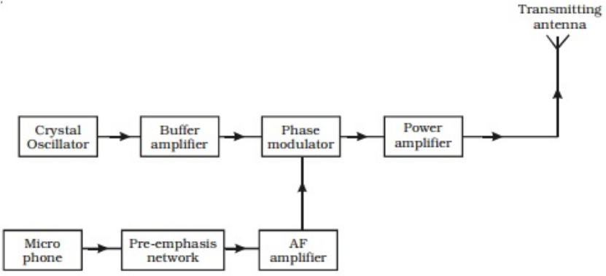
It consists of a crystal oscillator, which produces the carrier wave and the output of this is fed into the phase modulator. The buffer is a low frequency amplifier which isolates the crystal oscillator from the phase modulator.
The modulating signal is produced from a microphone. Since this AF modulating signal has uneven power, it is fed into a network called pre-emphasis network, where all the frequencies in the modulating signal are made to have equal power. The output of the pre-emphasis network is then amplified and sent for phase modulation. The modulated output is then power amplified using a power amplifier and then fed into the transmitting antenna for transmission.
There are two types of FM transmitters
1. Directly modulated (Variable Reactance Type) FM transmitter
2. Indirectly (phase) modulated FM transmitter
DIRECTLY MODULATED (VARIABLE REACTANCE TYPE) FM TRANSMITTER
- Direct frequency modulation can be employed using any of the FM circuits. However, direct FM at the final carrier frequency is not feasible because of the problem of maintaining high frequency stability of the carrier while at the same time obtaining adequate frequency deviation.
- To solve this problem, in directly modulated FM transmitters, the frequency modulation is carried out at a lower frequency and with a smaller frequency deviation. Then passing this FM wave through frequency multiplier circuit, the desired carrier frequency and desired frequency deviation is achieved.
- With frequency multiplication, the instantaneous frequency is multiplied.
- With frequency mixing, the deviation is not altered.
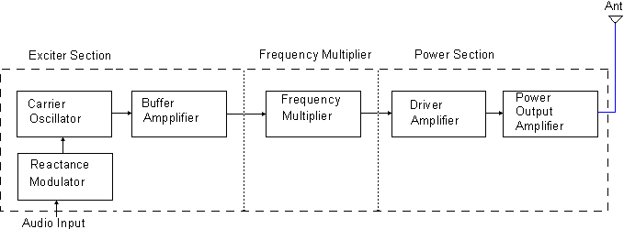
The FM transmitter has three basic sections.
- The exciter section contains the carrier oscillator, reactance modulator, and buffer amplifier.
- The frequency multiplier section features several frequency multipliers.
- The power output section, which includes a low-
level power amplifier, the final power amplifier, and the impedance matching network to properly load the power section with the antenna impedance.
The essential function of each circuit in the FM transmitter may be described as follows.

The Exciter
  - The function of the carrier oscillator is to generate
a stable sine wave signal at the rest frequency when no modulation is applied. It must be able to linearly change frequency when fully modulated, with no measurable change in amplitude.
  - The buffer amplifier acts as a constant high-
impedance load on the oscillator to help stabilize the oscillator frequency. The buffer amplifier may have a small gain.
  - The modulator acts to change the carrier oscillator frequency by application of the message signal. The positive peak of the message signal generally lowers the oscillator's frequency to a point below the rest frequency, and the negative message peak raises the oscillator frequency to a value above the rest frequency. The greater the peak-to-peak message signal, the larger the oscillator deviation.
- Frequency Multiplier: Frequency multipliers are tuned-input, tuned-output
RF amplifiers in which the output resonant circuit is tuned to a multiple of the input frequency. Common frequency multipliers are 2x, 3x, and 4x multiplication. A frequency multiplier is sometimes seen, but it’s extremely low efficiency forbids widespread usage. Note that multiplication is by whole numbers only. There cannot be a 1.5x multiplier, for instance.
- Power output section: The final power section develops the carrier power, to be transmitted and often has a low-power amplifier driven by the final power amplifier. The impedance matching network is the same as for the AM transmitter and matches the antenna impedance to the correct load on the final over-amplifier.
INDIRECTLY (PHASE) MODULATED FM TRANSMITTER:
- One of the difficulties encountered in FM transmitters which depend upon the direct method of frequency modulation is that because of the variable nature of the tuning of the tank circuit, crystal-controlled oscillators cannot be used and therefore the stability inherent in such crystal-controlled units is not available.
- An alternative technique for the generation of a frequency modulated signal which permits the use of crystal control is called the “Indirect Method”. In this technique, the phase angle is made to vary while holding the frequency constant.
- By this technique a phase modulated signal is generated and it can be passed off as an FM signal.
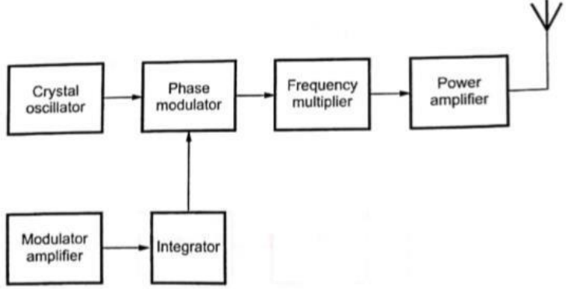
Phase Modulated FM Transmitter
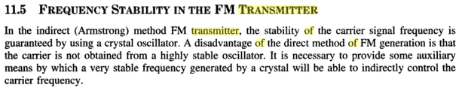
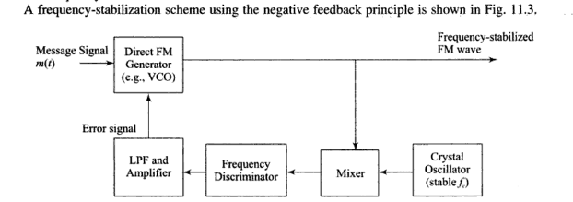
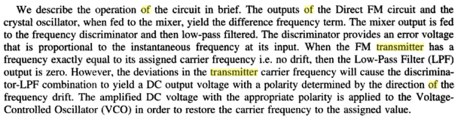
RADIO RECEIVERS:
The most familiar form of radio receiver is a broadcast receiver, often just called a radio, which receives audio programs intended for public reception transmitted by local radio stations. The sound is reproduced either by a loudspeaker in the radio or an earphone which plugs into a jack on the radio. The radio requires electric power, provided either by batteries inside the radio or a power cord which plugs into an electric outlet. All radios have a volume control to adjust the loudness of the audio, and some type of "tuning" control to select the radio station to be received.
CLASSIFICATION OF RADIO RECEIVERS:
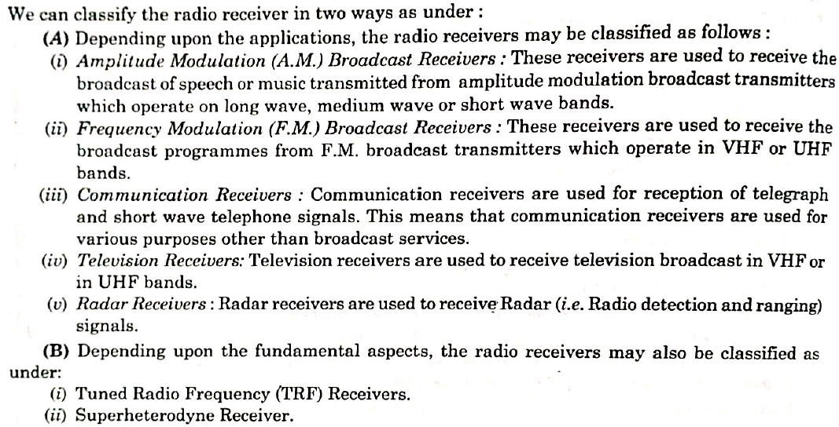
TUNED RADIO FREQUENCY RECEIVER (TRF);
The TRF, tuned radio frequency radio receiver was widely used in the early days of radio, but is hardly used today. The tuned radio frequency receiver is one in which the tuning or selectivity is provided at the radio frequency stages. The tuned radio frequency receiver was used in the early days of wire-less technology but it is rarely used today as other techniques offering much better performance are available.
Earliest tuned radio frequency receivers
It could be argued that the very earliest tuned radio frequency receivers were crystal sets. These sets used a single tuned network, sometimes consisting of a number of coils. The output from this was fed directly into a crystal or "Cat’s Whisker" detector and then into headphones. Although crystal radios are seldom used these days because their levels of performance can easily be exceeded by other forms of radio, they are ideal for showing some of the basic principles of radio.
Typically a TRF receiver would consist of three main sections:
Tuned radio frequency stages: This consisted of one of more amplifying and tuning stages. Early sets often had several stages, each proving some gain and selectivity.
Signal detector: The detector enabled the audio from the amplitude modulation signal to be extracted. It used a form of detection called envelope detection and used a diode to rectify the signal.
Audio amplifier: Audio stages to provide audio amplification were normally, but not always included.
The tuned radio frequency receiver was popular in the 1920s as it provided sufficient gain and selectivity for the receiving the broadcast stations of the day. However tuning took a little while as each stage in the early radios needed to be adjusted separately. Later ganged tuning capacitors were introduced, but by this time the superheterodyne receiver was becoming more widespread.
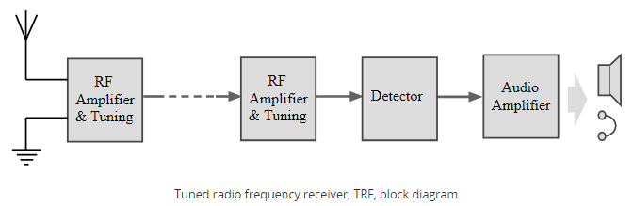
Modern tuned radio frequency receivers
- The TRF receiver has largely been disregarded in recent years. Other receiver topologies offer far better levels of performance, and with integrated circuit technology, the additional circuitry of other types of receiver is not an issue.
- There was one attempt at making a sufficiently selective tuned radio frequency receiver integrated circuit.
- The Ferranti ZN414 integrated circuit was introduced in 1972 and was successfully used in a number of designs. Later versions, the ZN415 and ZN416 included audio amplifiers.
- Performance of the chips was intended to allow operation on the medium wave band, up to frequencies of around 1.6 MHz. Generally the limit of operation of these chips was under 5 MHz.
- However with the demise of the Ferranti company, the design stopped production. However there have been a few replacement ICs on the market. These include: MK484, YS414, TA7642, UTC7642, LMF501T, LA1050. These can sometimes be purchased on the open market and used in small radios to fit in matchboxes, etc.
SUPERHETERODYNE RECEIVER
There are some key circuit blocks that form the basic superheterodyne receiver. Although more complicated receivers can be made, the basic circuit is widely used – further blocks can add improved performance or additional functionality and their operation within the whole receiver is normally easy to determine once the basic block diagram is understood.
RF tuning & amplification: This RF stage within the overall block diagram for the receiver provides initial tuning to remove the image signal. It also provides some amplification. If noise performance for the receiver is important, then this stage will be designed for optimum noise performance. This RF amplifier circuit block will also increase the signal level so that the noise introduced by later stages is at a lower level in comparison to the wanted signal.
Local oscillator: The local oscillator circuit block can take a variety of forms. Early receivers used free running local oscillators. Today most receivers use frequency synthesizers, normally based around phase locked loops. These provide much greater levels of stability and enable frequencies to be programmed in a variety of ways.
Mixer: Both the local oscillator and incoming signal enter this block within the superheterodyne receiver. The wanted signal is converted to the intermediate frequency.
IF amplifier & filter: This superheterodyne receiver block provides the majority of gain and selectivity. High performance filters like crystal filters may be used, although LC or ceramic filters may be used within domestic radios. The standard value for Intermediate frequency (IF) in AM receivers is 455 KHz.
Demodulator: The superheterodyne receiver block diagram only shows one demodulator, but in reality radios may have one or more demodulators dependent upon the type of signals being receiver.
Audio amplifier: Once demodulated, the recovered audio is applied to an audio amplifier block to be amplified to the required level for loudspeakers or headphones. Alternatively the recovered modulation may be used for other applications whereupon it is processed in the required way by a specific circuit block.
Super heterodyne receiver block diagram explanation
Signals enter the receiver from the antenna and are applied to the RF amplifier where they are tuned to remove the image signal and also reduce the general level of unwanted signals on other frequencies that are not required.
The signals are then applied to the mixer along with the local oscillator where the wanted signal is converted down to the intermediate frequency. Here significant levels of amplification are applied and the signals are filtered. This filtering selects signals on one channel against those on the next. It is much larger than that employed in the front end.The advantage of the IF filter as opposed to RF filtering is that the filter can be designed for a fixed frequency. This allows for much better tuning. Variable filters are never able to provide the same level of selectivity that can be provided by fixed frequency ones.
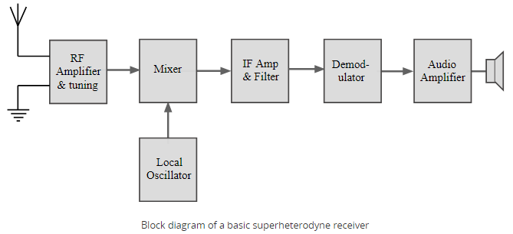
Once filtered the next block in the superheterodyne receiver is the demodulator. This could be for amplitude modulation, single sideband, frequency modulation, or indeed any form of modulation. It is also possible to switch different demodulators in according to the mode being received. The final element in the superheterodyne receiver block diagram is shown as an audio amplifier, although this could be any form of circuit block that is used to process or amplified the demodulated signal.
Various Blocks of AM Superheterodyne Receiver:
1. RF section and Characteristics
2. Frequency Changing and Tracking
3. Intermediate Frequencies and IF amplifiers
4. Detection and Automatic Gain Control
1. RF Section and Characteristics:
A radio receiver always has an RF section, which is a tunable circuit connected to the antenna terminals. It is there to select the wanted frequency and reject some of the unwanted frequencies.
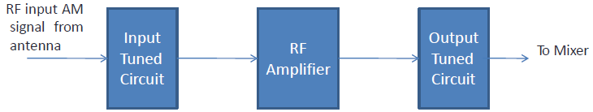
A Simplified Block Diagram of RF Front-end
Reasons for use and functions of RF amplifier:
- Greater gain i.e better sensitivity
- Improved image-frequency rejection
- Improved signal-to-noise ratio
- Improved rejection of adjacent unwanted signals, i.e better selectivity
- Better coupling of the receiver to the antenna
- Prevention of spurious frequencies from entering the mixer and heterodyning there to produce an interfering frequency equal to the IF from the desired signal.
- Prevention of re-radiation of the local oscillator through the antenna of the receiver.
- The single tuned transformer coupled amplifier is most commonly employed for RF amplification, as illustrated in below figure.
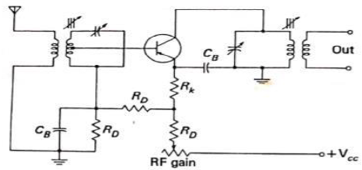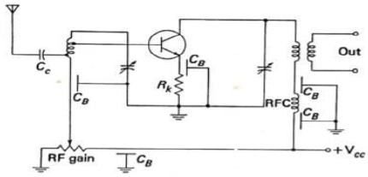
Figure: (a) Transistor RF amplifer (Mid frequency) Figure: (b) Transistor RF amplifer (VHF)
2. Frequency Changing and Tracking:
- The mixer is a non-linear device having two sets of input terminals and one set of output terminals.
- The signal from the antenna or from the preceding RF amplifier is fed to one set of input terminals, and the output of the local oscillator is fed to the other set . Such a non-linear circuit will have several frequencies present in its output, including the difference between the two input frequencies in AM this was called the lower sideband.
- The most common types of mixers are the bipolar transistor, FET, Dual-gate MOSFET and integrated circuit.
Separately Excited Mixer: In this circuit, one device acts as a mixer while the other supplies the necessary oscillations.
- In this circuit, T1 the FET, is the mixer, to whose gate is fed to the output of T2, the bipolar transistor Hartley oscillator.
- If T1 were a Dual-gate MOSFET, the RF input would be applied to one of the gates, rather than to the source as shown in figure, with the local oscillator output going to the other gate, just as it goes to the single gate here.
- The ganging together of the tuning capacitors across the mixer and oscillator coils, and that each in practice has a trimmer across it for fine adjustment by the manufacturer.
- The output is taken through a double tuned transformer in the drain of the mixer and fed to the IF amplifier.
- In domestic receivers, a self-excited mixer is more likely to be encountered.

Self-Excited Mixer:
- At the signal frequency the collector and emitter tuned circuits may be considered as being effectively short circuited so that we have an amplifier with an input tuned circuit and an output that is indeterminate.
- At the IF, we have an amplifier those input comes from an indeterminate source, and whose output is tuned to the IF. Both these amplifiers are CE amplifiers.
Tracking:
- The superheterodyne receiver has number of tunable circuits which must all be tuned correctly if any given station is to be received.
- The ganged tuning is employed to do this work, which mechanically couples all tuning circuits so that only one tuning control or dial is required.
- Usually there are three tuned circuits: Antenna or RF tuned circuit, mixer tuned circuit and local oscillator tuned circuit. All these circuits must be tuned to get proper RF input and to get IF frequency at the output of the mixer.
- The process of tuning circuits to get the desired output is called tracking.
- Any error that exists in the frequency difference will result in an incorrect frequency being fed to the IF amplifier. Such errors are known as “Tracking errors” and these must be avoided.
- To avoid tracking errors standard capacitors are not used, and ganged capacitors with identical sections are used. A different value of inductance and special extra capacitors called trimmers and padders are used to adjust the capacitance of the oscillator to the proper range.
- There are three common methods used for tracking.
- Padder Tracking
- Trimmer Tracking
- Three-Point Tracking
Padder tracking: The oscillator tunes below the frequency it should be in mid-band, so the IF created higher than it should be, and positive error is created as shown in figure (b).
Figure: (a) Padder Tracking Figure: (b) Tracking error in Padder Tracking
Trimmer Tracking: In this tracking, the oscillator tunes higher frequency it should be in mid-band, so IF created is less than it should be, and negative error is created as shown in figure (b).
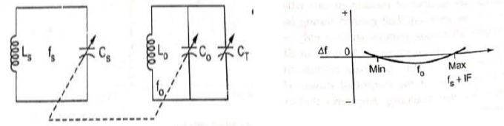
Figure: (a) Trimmer Tracking Figure: (b) Tracking error in Trimmer Tracking
Three Point Tracking: The combination circuit called three point tracking can be adjusted to give zero error at three points across the band, at each end, and at the middle.
3. Intermediate Frequencies and IF amplifiers: The following are the major factors influencing the choice of the intermediate frequency in any particular system
a. If the IF is too high, poor selectivity and poor adjacent channel rejection result unless sharp cutoff filters are used in the IF stages.
b. A high value of IF increases tracking difficulties
c. As the IF is lowered, image frequency rejection becomes poorer.
d. A very low IF can make the selectivity too sharp, cutting off the sidebands. This problem arises because the Q must be low when the IF is low and therefore the gain per stage is low.
e. If IF is very low, the frequency stability of the local oscillator must be made correspondingly higher because any frequency drift is now a larger properties of the low IF than of a high IF.
f. The IF must not fall within the tuning range of the receiver, or else instability will occur and heterodyne whistles will be heard, making it impossible to tune to the frequency band immediately adjacent to the IF.
Frequencies Used:
- Standard broadcast AM receivers use an IF within the 438- 465 KHz range, with 455 KHz by far the most popular frequency.
- AM, SSB and other receivers employed for shortwave or VHF reception have a first IF often in the range from about 1.6 to 2.3MHz, or else above 30 MHz.
- FM receivers using the standard 88-108 MHz band have an IF which is almost always 10.7 MHz.
- Television receivers in the VHF band and in the UHF band uses an IF between 26 and 46 MHz, with approximately 36 and 46 MHz the two most popular values.
- Microwave and Radar receivers, operating on frequencies in the 1-10 GHz range, use intermediate frequencies depending on the application, with 30, 60 and 70 MHz among the most popular.
IF Amplifiers
- The abbreviation “IF” refers to an intermediate frequency itself or, more generally, to intermediate-frequency-based techniques.
- As the name implies, an intermediate frequency is somewhere between the baseband frequency and the carrier frequency.
- IF circuitry can be incorporated into both transmitters and receivers, though the benefits of IF techniques are more relevant to receivers.
- We’ll discuss IF in the context of receiver design, but as you’re reading keep in mind that these beneficial characteristics could apply to transmitters as well.
IF Benefits
- Many RF systems incorporate an intermediate frequency (IF) that is lower than the carrier frequency and higher than the baseband frequency.
- An IF-based receiver is known as a heterodyne receiver.
- The use of an IF simplifies the design of tunable receivers and reduces the number of components that must be compatible with high frequencies.
- IF architectures simplify the design of bandpass filters because the reduced center frequency results in a lower Q-factor requirement.
- An IF-based system allows for a more robust implementation of demodulation.
- The IF amplifier is a fixed-frequency amplifier with the very important function of rejecting adjacent unwanted frequencies. It should have a frequency response with steep skirts.
- FET and integrated circuit IF amplifiers generally are double tuned at the input and at the output, bipolar transistor amplifiers often are single tuned.
- The above circuit is two stage amplifier, with all IF transformers single tuned. This departure from a single stage, double tuned amplifier is for the sake of extra gain and receiver sensitivity.
- If a double tuned transformers were used, both sides of it might have to be tapped, rather than just one side as with a single tuned transformer. Thus a reduction in a gain.
- Detection and Automatic Gain Control
This simple diode detector has the disadvantages that Vo, in addition to Vin proportional to the modulating voltage, also has a DC component, which represents the average envelope amplitude (carrier strength), and small RF ripple. The unwanted components are removed in a practical detector, leaving only the intelligence and some second harmonic of the modulating signal.
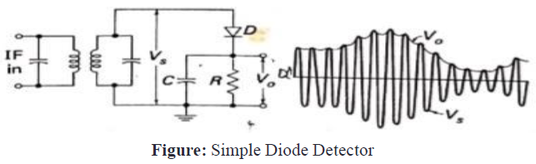
Automatic Gain Control (AGC):
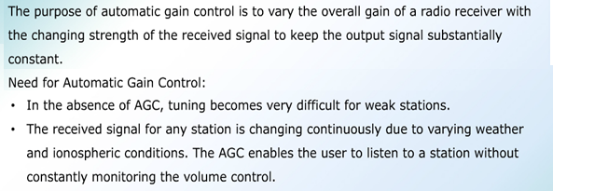
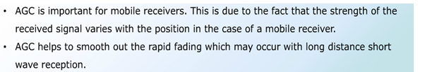
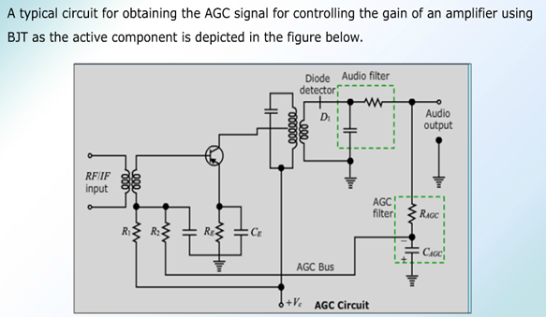
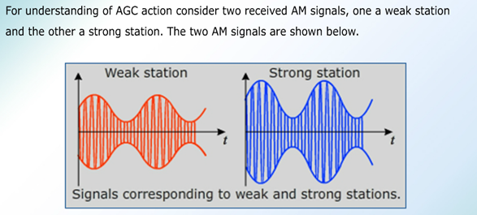
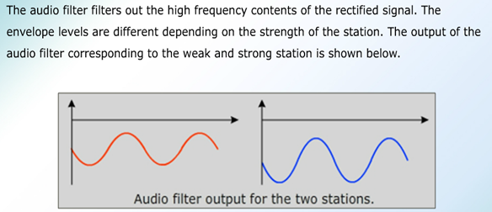
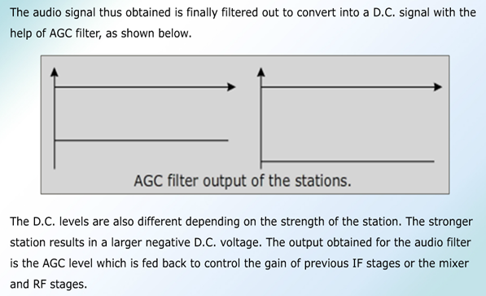
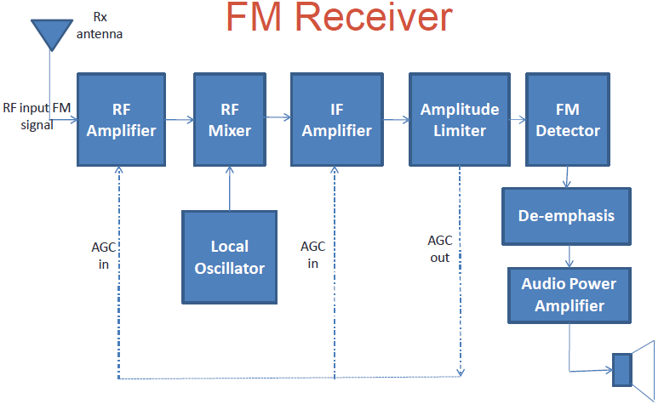
Amplitude Limiting
- In order make full use of the advantages offered by FM, a demodulator must be preceded by amp. Limiter, any amplitude changes in the signal fed to the FM demodulators are spurious.
- They must be removed if distortion is to be avoided
- Since most FM demodulators react to amplitude changes as well as frequency changes
- The limiter is a form of clipping device, a circuit whose output tends to remain constant despite changes in the input signal.
Figure: Amplitude Limiter
- The Drain supply voltage has been dropped through resistor.
- The bias on the gate is leak type bias supplied by the parallel Rg-Cg combination.
- Finally, FET is neutralized by means of capacitor C_{N}, in consideration of the high frequency of operation.
- Leak type bias provides limiting, as shown in figure. When the input signal voltage rises, current flows in the Rg-Cg bias circuit, and a negative voltage is developed across the capacitor.
- The bias on the FET is increased in proportion to the size of the input voltage. As a result the gain of the amplifier is lowered, and the output voltage tends to remain constant.
Figure: Amplitude Limiter Transfer Characteristics
Figure: Typical Limiter response characteristics
- Shows the response characteristic of the Amplitude Limiter in FM Receiver. It indicates clearly that limiting takes place only for a certain range of input voltages, outside which output varies with input.
- Referring to Fig.,we see that as input increases from value 1 to value 2, output current also rises. Thus no limiting has yet taken place.
- However, comparison of 2 and 3 shows that they both yield the same output current and voltage. Thus limiting has now begun. Value 2 is the point at which limiting starts and is called the threshold of limiting.
- As input increases from 3 to 4, there is no rise in output; all that happens is that the output current flows for a somewhat shorter portion of the input cycle. This, of course, suggests operation like that of a class C amplifier. Although some limiting is achieved by this process, it is insufficient by itself, the action just described would occur only with rather large input voltages.
- To overcome this, early saturation of the output current is used, achieved by means of a low drain supply voltage. This is the reason for the drain dropping resistor of Figure
- The supply voltage for a limiter is typically one-half of the normal dc drain voltage.
- The result of early saturation is to ensure limiting for conveniently low input voltages.
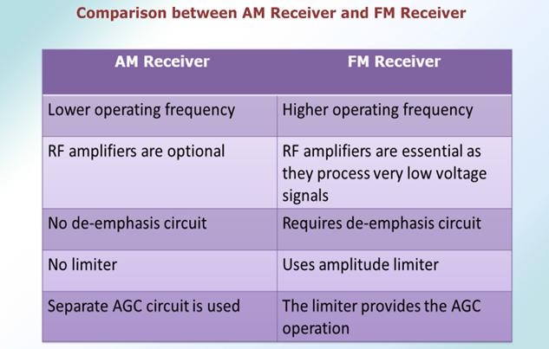
Communication Receiver Block Diagram: A Communication Receiver Block Diagram is one whose main function is the reception of signals used for communications rather than for entertainment. It is a radio receiver designed to perform the tasks of low- and high-frequency reception much better than the type of set found in the average household. In turn, this makes the communications receiver useful, in other applications, such as the detection of signals from high-frequency impedance bridges (where it is used virtually as a high-sensitivity tuned voltmeter), signal-strength measurement, frequency measurement and even the detection and display of individual components of a high-frequency wave (such as an FM wave with its many sidebands). It is often operated by qualified people, so that any added complications in its tuning and operation are not necessarily detrimental, as they would be in a receiver to be used by the general public.
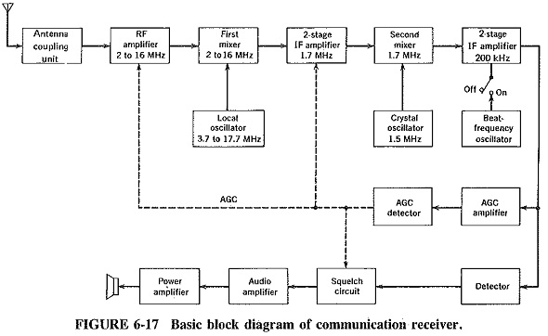
Extensions of the Superheterodyne Principle:
Some of the circuits found in communications receivers,’ such as tuning indicators and beat-frequency oscillators, may be said to be mere additions, other circuits are really extensions of the superheterodyne principle. Delayed AGC and double conversion are” but two of these circuits. It has been found convenient to subdivide the topic into extensions of the superheterodyne principle and additions to it.
Input stages: It is common to have one, or sometimes even two, stages of RF amplification. Two stages are preferable if extremely high sensitivity and low noise are required, although some complications in tracking are bound to occur. Regardless of the number of input stages, some system of band changing will have, to be used if the receiver is to cover a wide frequency range, as nearly all Communication Receiver Block Diagram do. This is compounded by the fact that the normal variable capacitor cannot be relied upon to cover a frequency ratio much in excess of 2: 1 at high frequencies. Band changing is accomplished in either of two ways by switching in the required RF, mixer and local oscillator coils, or by frequency synthesis. The use of synthesis is a clear favourite in modern receivers.
Fine tuning: As the name implies, fine tuning permits stations transmitting on frequencies very close to each other to be separated, or resolved, by the receiver. This ability is essential in a Communication Receiver Block Diagram. Some good-quality domestic receivers provide an electrical fine-tuning control, using a separate dial. In this method, the local oscillator frequency is varied by means of a trimmer on either side of the main tuning control setting, and in this fashion close stations are separated. Similar results can be achieved with a mechanical vernier control, and indeed this is how fine tuning, or bandspread, used to be provided in communications receivers. These days, the use of frequency synthesis, as in the receiver of Figure 6-18, is almost invariable in commercial communications receivers.
Double conversion Communications receivers and some high-quality domestic AM receivers have more than one intermediate frequency generally two, but sometimes even more. When a receiver has two different IFs, as does the one shown in block diagram form in Figure 6-17, it is then said to be a double-conversion receiver. The first IF is high, several megahertz or even higher, and sometimes not even a fixed frequency. The second IF is quite low, of the order of 1 MHz or even less. After leaving the RF amplifier, the signal in such a receiver is still mixed with the output of a local oscillator. This is similar to the local oscillator of a domestic receiver, except that now the resulting frequency difference is a good deal higher than 455 kHz. The high intermediate frequency is then amplified by the high-frequency IF amplifier, and the output is fed to a second mixer and mixed with that of a second local oscillator. Since the second local oscillator frequency is normally fixed, this could be a crystal oscillator, and in fact very often is, in non-synthesized receivers. The low second intermediate frequency is amplified by an LF IF amplifier and then detected in the usual manner.
Double conversion is desirable in communications receivers. As will be recalled from Section 6-2.3, the intermediate frequency selected for any receiver is bound to be a compromise since there are equally compelling reasons why it should be both high and low. Double conversion avoids this compromise. The high first intermediate frequency pushes the image frequency farther away from the signal frequency and therefore permits much better attenuation of it. The low second IF, on the other hand, has all the virtues of a low fixed operating frequency, particularly sharp selectivity and hence good adjacent-channel rejection.

